Software Requirements Specification

Version 1.0

<<Annotated Version>>

June 17, 2020

Clothes store requirements analysis

Ali Issa Ibrahem

Ali Ammar

Majd Awwad

# Table of Contents

Table of Contents i

List of Figures ii

1.0. Introduction 1

1.1. Purpose 1

1.2. Scope of Project 1

1.3. Glossary 2

1.4. References 2

1.5. Overview of Document 2

2.0. Overall Description 4

2.1 System Environment 4

2.2 Functional Requirements Specification 5

2.2.1 The Saler Use Case 1 5

Use case: **Sale** 5

2.2.2 The Saler Use Case 2 6

Use case: **Daily inventory** 6

2.2.3 The Saler Use Case 3 7

Use case: **Replay the widget** 7

2.2.4 The Saler Use Case 4 8

Use case: **The Findings** 8

2.3 User Characteristics 9

2.4 Non-Functional Requirements 9

3.0. Requirements Specification 10

3.1 External Interface Requirements 10

3.2 Functional Requirements 10

3.3 Detailed Non-Functional Requirements 10

3.3.1 Remind the seller to make sure not to use or use any of the returned parts 10

3.3.2 Having a printer 10

# 

# List of Figures

Figure 1 - System Environment 4

Figure 2 - The Seller

Figure 3 - The Seller

Figure 4 - The Seller

Figure 5 - The Seller Use Case 4………………………………………………..……………………………8

# 

# 1.0. Introduction

## 1.1. Purpose

The purpose of this document is to provide a detailed description of the clothing shop requirements analysis system. It will explain the purpose and features of the system, system interfaces, what the system will do, the constraints under which it must operate, and how the system will interact with external stimuli. This document is intended for both stakeholders and system developers.

## 1.2. Scope of Project

This software system will be a clothing store requirements analysis system for a local editor. It is a clothing store that sells its assets (jeans - sweaters - shirts - pajamas) according to the imposed rates.

Subject to a discount of one thousand pounds when buying 3 pieces.

The sale process is based on observing that the quantity of the pieces is nearing expiration so that the seller is reminded when the remaining number of pieces reaches a certain limit determined by the seller in order to buy new pieces.

At the end of each day, he performs a daily inventory of the amount of the sale.

In the event that anything from the parts is returned by the buyer, the seller will be reminded and alerted to ensure that it is not used.

Note that the buyer gets an invoice when purchasing anything from the assets.

## 1.3. Glossary

|  |  |
| --- | --- |
| **Term** | **Definition** |
| The Seller | It is the main element in the system, as it performs the daily sale and inventory process, checks the parts in case they are returned from the customer, and checks the quantity of the parts. |
| Sale | Before starting this use case, the seller has already opened the software and then does the following:  He sells his assets (jeans, sweaters, shirts, and pajamas) according to the imposed prices.  Subject to a discount of one thousand pounds when buying 3 pieces. |
| Daily inventory | At the end of each day, the seller makes a daily inventory of the amount of the sale. |
| Replay the widget | In the event that anything from the parts is returned by the buyer, the seller will be reminded and alerted to ensure that it is not used,  The seller is also reminded to check the part whether it is still valid for any damage or not. |
| The Findings | The sale process is based on observing that the quantity of the pieces is close to end so that the seller is reminded when the remaining number of pieces reaches a certain limit determined by the seller in order to buy new pieces. |

## 1.4. References

IEEE. *IEEE Std 830-1998 IEEE Recommended Practice for Software Requirements Specifications.* IEEE Computer Society, 1998.

## 1.5. Overview of Document

The next chapter, the Overall Description section, of this document gives an overview of the functionality of the product. It describes the informal requirements and is used to establish a context for the technical requirements specification in the next chapter.

The third chapter, Requirements Specification section, of this document is written primarily for the developers and describes in technical terms the details of the functionality of the product.

Both sections of the document describe the same software product in its entirety, but are intended for different audiences and thus use different language.

# 2.0. Overall Description

## 2.1 System Environment

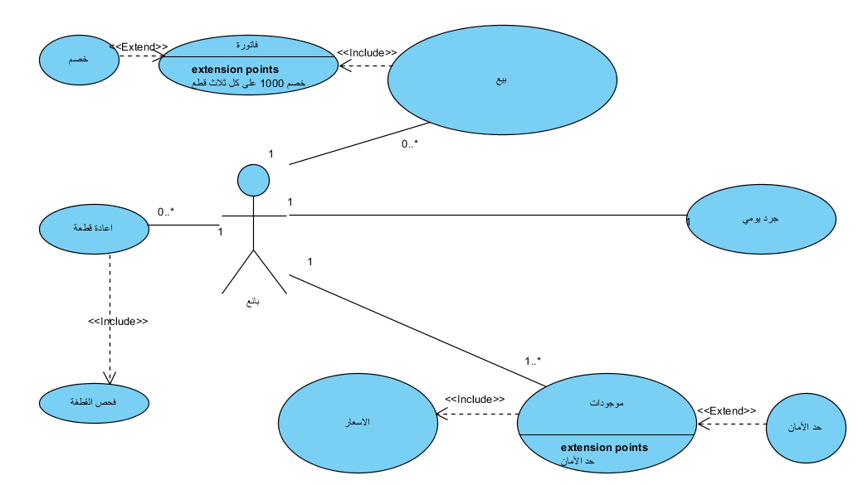Figure 1 - System Environment

The system consists of an active actor and is the seller.

Where the seller does the following:

Enter the amount of the assets (jeans, sweaters, shirts, and pajamas) according to the measurements , Entering asset prices , Entering the safety limit for each class of assets, Entering the number of pieces found in each type and item , Carry out a daily inventory, Issue an invoice when selling to each customer, Deduction of one thousand liras from the total price when buying 3 pieces.

## 2.2 Functional Requirements Specification

This section describes the seller's use cases separately. The seller has four use cases and is the main regulator in this system.

2.2.1 The Seller Use Case 1

#### Use case: Sale

**Diagram:**

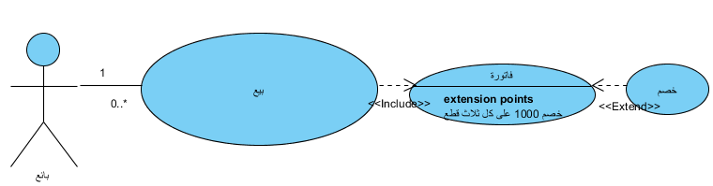

**Figure 2 - The Seller Use Case 1**

**Initial Step-By-Step Description**

Before starting this use case, the seller has already opened the software and then does the following:

He sells his assets (jeans, sweaters, shirts, and pajamas) according to the imposed prices.

Subject to a discount of one thousand pounds when buying 3 pieces.

### 

### 2.2.2 The Seller Use Case 2

#### Use case: Daily inventory

**Diagram:**

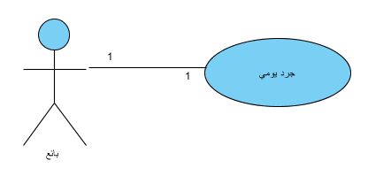

**Figure 3 - The Seller Use Case 2**

**Initial Step-By-Step Description**

At the end of each day, the seller makes a daily inventory of the amount of the sale.

### 

### 2.2.3 The Seller Use Case 3

#### Use case: Replay the widget

**Diagram:**

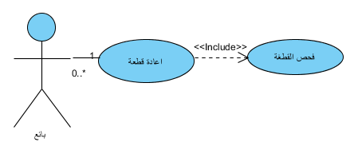

**Figure 4 - The Seller Use Case 3**

**Initial Step-By-Step Description**

In the event that anything from the parts is returned by the buyer, the seller will be reminded and alerted to ensure that it is not used,

The seller is also reminded to check the part whether it is still valid for any damage or not.

### 2.2.4 The Seller Use Case 4

#### Use case: The Findings

**Diagram:**

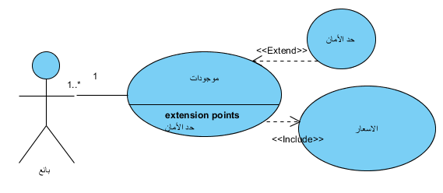

**Figure 5 - The Seller Use Case 4**

**Initial Step-By-Step Description**

The sale process is based on observing that the quantity of the pieces is close to end so that the seller is reminded when the remaining number of pieces reaches a certain limit determined by the seller in order to buy new pieces.

## 

## 2.3 User Characteristics

The seller does the following:

1- Selling his assets (jeans, sweaters, shirts, and pajamas) according to the imposed prices.

2- Take into account a discount of one thousand pounds when buying 3 pieces.

3- Taking into consideration the near end of the quantity of the pieces, in order to buy new pieces.

4- At the end of each day, he performs a daily inventory of the amount of the sale.

5- Consider checking the parts in case of return by the customer.

6- Submit a purchase invoice to the customer.

## 2.4 Non-Functional Requirements

1- Remind the seller to make sure not to use or use any of the returned parts.

2- Having a printer.

# 3.0. Requirements Specification

## 3.1 External Interface Requirements

## Acquire a computer and a Java emulator program (NetBeans) and a programmer specializing in this language, and obtain bills for all goods in the store, with a printer and paper.

## 3.2 Functional Requirements

1- Enter the amount of the assets (jeans, sweaters, shirts, and pajamas) according to the measurements.

2- Entering asset prices.

3- Entering the safety limit for each class of assets.

4- Entering the number of pieces found in each type and item.

5- Carry out a daily inventory.

6- Issue an invoice when selling to each customer.

7- Deduction of one thousand liras from the total price when buying 3 pieces.

## 3.3 Detailed Non-Functional Requirements

3.3.1 Remind the seller to make sure not to use or use any of the returned parts:

### In the event that any item previously purchased by the customer is returned, the system will alert the seller by message to ensure the safety and correctness of the returned item.

### 3.3.2 Having a printer:

The seller must purchase a printer in order to document and print the invoice and give it to the customer.

# 